**W3C Validation Results**

index.html

aboutus.html

rehoming.html

successstories.html

application.html

contactus.html

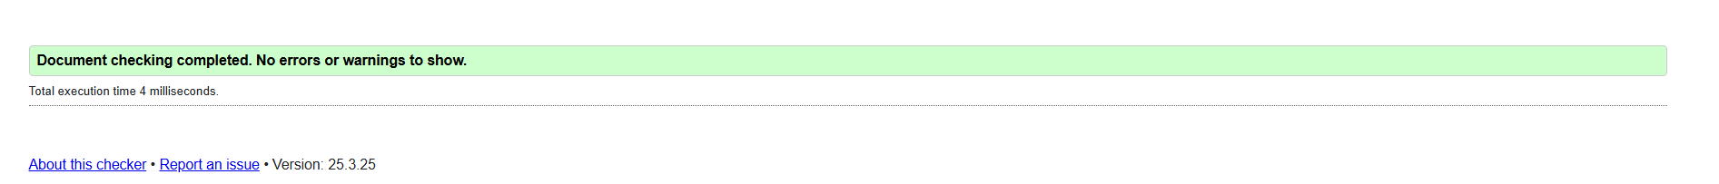styles.css